**Working Papers**

**Students seeking employment before turning 18 years of age are required, by law, to have working papers.  Applications and information about obtaining working papers can be found below.**

**The Application For Working Papers can be found on the CEC website under CSL > Internship Opportunities > Additional Resources**

**Pennsylvania Department of Labor – State Child Labor Law**

The Child Labor Act provides for the health, safety and welfare of minors by:

* Prohibiting their employment or work in certain establishments and occupations;
* Under certain ages, restricting their hours of labor;
* Regulating certain conditions of their employment; and
* Requiring employment certificates (general or vacation) for minors under the age of 18.

**Where do to take your Permit Application**

**Each** school district is responsible for issuing work permits to all minors who reside in the district. Contact your school district, or search online, to find out which building you should go to and what hours the issuing officer is available.

**Hours of Employment**

**There are different hours of employment restrictions for minors aged 14/15, and for minors aged 16/17. Please see grid below for the regulations for both age groups.**

**Note! There are different restrictions for hours during the school week/year than there are for during vacation time.**

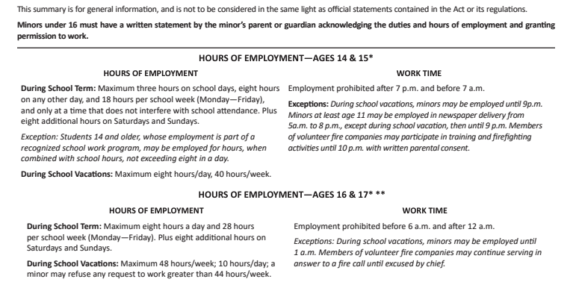

**Frequently Asked Questions**

**Q: Does a parent or legal guardian have to appear in person before an issuing officer?  
A: No, the Pennsylvania Child Labor Act indicates that the parent or legal guardian does not have to appear in person before the issuing officer.**

**Q: Does a minor need to have a job offer in order to obtain a work permit?  
A: No. Of course, a minor can apply for and accept a job offer prior to obtaining a work permit. Once the work permit is issued, the minor may begin work.**

**Q: What is the procedure for getting a work permit?  
A: An application for a work permit can be obtained at your local school district. The parent or legal guardian must sign the application.**

**Q: What are acceptable proofs of age accepted for work permit applications?  
A: The following is the order of preference for acceptable proof of age:**

1. **An attested transcript of the birth certificate, filed according to law with a register of vital statistics or other officer charged with the duty of recording births.**
2. **A certified baptismal certificate or transcript of the record of baptism showing the date of birth.**
3. **A passport showing the age of the minor.**
4. **Any certified documentary record of age other than a school record or an affidavit of age, which appears to the satisfaction of the issuing officer to be sufficient evidence of age.**
5. **The signed statement of a physician, physician's assistant or nurse practitioner, approved by the board of school directors, stating that, after examination, it is the opinion of the individual signing the statement that the applicant has attained the age required by law for the occupation in which the applicant expects to engage.**

**Q: Must the minor appear in person before the issuing officer to receive a work permit?  
A: The work permit certifies that the minor has personally appeared before the issuing officer and has been examined and that all papers have been examined, approved and filed. This certifies that all conditions and requirements for issuing a permit have been fulfilled. The work permit is then signed by the minor in the presence of the issuing officer.**

**Q: Can minors under the age of 14 be employed? If so, do they need a work permit?  
A: Yes, minors under the age of 14 can be employed in certain situations; however, they do not need to obtain a work permit. Minors under the age of 14 can be employed as follows: (1) an individual who is at least 12 years of age may be employed as a caddy if the minor does not carry more than one golf bag at a time and employment is not for more than 18 holes of golf in a single day and (2) an individual who is at least 11 years of age may deliver newspapers.**

**Q: Are there certain occupations or jobs that a minor cannot perform?  
A: Yes. Under the Pennsylvania Child Labor Act, Section 4, titled "Occupations and establishments", minors may not be employed in hazardous or otherwise prohibited establishments or occupations. For more information review**[**Section 4 of the Pennsylvania Child Labor Act**](https://www.legis.state.pa.us/CFDOCS/LEGIS/LI/uconsCheck.cfm?txtType=HTM&yr=2012&sessInd=0&smthLwInd=0&act=0151.&CFID=341765195&CFTOKEN=69173171)**.**